Introduction to Data Science

Midterm Project Report
Dataset: Cars93 (MASS package, Rdatasets)
Source: https://vincentarelbundock.github.io/Rdatasets/articles/data.html

Name | ID | Sign
Md. Tawfiqul Islam Tamal | 23-52978-3
Ashadullah Hil Galib | 22-49555-3
Md. Omar Faruk Prodhan | 22-49237-3
Syed Md. Saifullah Saif | 22-49246-3

1. Dataset Description
The dataset used in this project is Cars93, originally distributed with the MASS package in R and hosted on the Rdatasets repository (https://vincentarelbundock.github.io/Rdatasets/articles/data.html). It contains information on 93 car models sold in the United States during the year 1993, collected from Consumer Reports and the PACE Buying Guide. The dataset has 27 original features (28 including the row index), covering both numerical attributes such as Price, Horsepower, MPG (city and highway), Engine Size, Weight, Length, Wheelbase, and Fuel Tank Capacity, and categorical attributes such as Manufacturer, Type, AirBags, DriveTrain, Cylinders, Man.trans.avail, and Origin. This mix of more than 10 numerical and categorical features makes it suitable for demonstrating the full data preparation pipeline: missing value handling, noise handling, invalid data checking, normalization, transformation, outlier detection, descriptive statistics, train-test splitting, and feature selection.

2. Loading the Dataset
Code:

mydata <- read.csv("Cars93.csv", header = TRUE, sep = ",")
str(mydata)
print(summary(mydata))
print(dim(mydata))
Output:

> mydata <- read.csv("Cars93.csv", header = TRUE, sep = ",")
> str(mydata)
'data.frame': 93 obs. of 28 variables:
$ rownames : int 1 2 3 4 5 6 7 8 9 10 ...
$ Manufacturer : chr "Acura" "Acura" "Audi" "Audi" ...
$ Model : chr "Integra" "Legend" "90" "100" ...
$ Type : chr "Small" "Midsize" "Compact" "Midsize" ...
$ Min.Price : num 12.9 29.2 25.9 30.8 23.7 14.2 19.9 22.6 26.3 33 ...
$ Price : num 15.9 33.9 29.1 37.7 30 15.7 20.8 23.7 26.3 34.7 ...
$ Max.Price : num 18.8 38.7 32.3 44.6 36.2 17.3 21.7 24.9 26.3 36.3 ...
$ MPG.city : int 25 18 20 19 22 22 19 16 19 16 ...
$ MPG.highway : int 31 25 26 26 30 31 28 25 27 25 ...
$ AirBags : chr "None" "Driver & Passenger" "Driver only" "Driver & Passenger" ...
$ DriveTrain : chr "Front" "Front" "Front" "Front" ...
$ Cylinders : chr "4" "6" "6" "6" ...
$ EngineSize : num 1.8 3.2 2.8 2.8 3.5 2.2 3.8 5.7 3.8 4.9 ...
$ Horsepower : int 140 200 172 172 208 110 170 180 170 200 ...
$ RPM : int 6300 5500 5500 5500 5700 5200 4800 4000 4800 4100 ...
$ Rev.per.mile : int 2890 2335 2280 2535 2545 2565 1570 1320 1690 1510 ...
$ Man.trans.avail : chr "Yes" "Yes" "Yes" "Yes" ...
$ Fuel.tank.capacity: num 13.2 18 16.9 21.1 21.1 16.4 18 23 18.8 18 ...
$ Passengers : int 5 5 5 6 4 6 6 6 5 6 ...
$ Length : int 177 195 180 193 186 189 200 216 198 206 ...
$ Wheelbase : int 102 115 102 106 109 105 111 116 108 114 ...
$ Width : int 68 71 67 70 69 69 74 78 73 73 ...
$ Turn.circle : int 37 38 37 37 39 41 42 45 41 43 ...
$ Rear.seat.room : num 26.5 30 28 31 27 28 30.5 30.5 26.5 35 ...
$ Luggage.room : int 11 15 14 17 13 16 17 21 14 18 ...
$ Weight : int 2705 3560 3375 3405 3640 2880 3470 4105 3495 3620 ...
$ Origin : chr "non-USA" "non-USA" "non-USA" "non-USA" ...
$ Make : chr "Acura Integra" "Acura Legend" "Audi 90" "Audi 100" ...
> print(summary(mydata))
rownames Manufacturer Model
Min. : 1 Length :93 Length :93
1st Qu.:24 N.unique :32 N.unique :93
Median :47 N.blank : 0 N.blank : 0
Mean :47 Min.nchar: 3 Min.nchar: 2
3rd Qu.:70 Max.nchar:13 Max.nchar:14
Max. :93

Type Min.Price Price
Length :93 Min. : 6.70 Min. : 7.40
N.unique : 6 1st Qu.:10.80 1st Qu.:12.20
N.blank : 0 Median :14.70 Median :17.70
Min.nchar: 3 Mean :17.13 Mean :19.51
Max.nchar: 7 3rd Qu.:20.30 3rd Qu.:23.30
Max. :45.40 Max. :61.90

Max.Price MPG.city MPG.highway
Min. : 7.9 Min. :15.00 Min. :20.00
1st Qu.:14.7 1st Qu.:18.00 1st Qu.:26.00
Median :19.6 Median :21.00 Median :28.00
Mean :21.9 Mean :22.37 Mean :29.09
3rd Qu.:25.3 3rd Qu.:25.00 3rd Qu.:31.00
Max. :80.0 Max. :46.00 Max. :50.00

AirBags DriveTrain Cylinders
Length :93 Length :93 Length :93
N.unique : 3 N.unique : 3 N.unique : 6
N.blank : 0 N.blank : 0 N.blank : 0
Min.nchar: 4 Min.nchar: 3 Min.nchar: 1
Max.nchar:18 Max.nchar: 5 Max.nchar: 6

EngineSize Horsepower RPM
Min. :1.000 Min. : 55.0 Min. :3800
1st Qu.:1.800 1st Qu.:103.0 1st Qu.:4800
Median :2.400 Median :140.0 Median :5200
Mean :2.668 Mean :143.8 Mean :5281
3rd Qu.:3.300 3rd Qu.:170.0 3rd Qu.:5750
Max. :5.700 Max. :300.0 Max. :6500

Rev.per.mile Man.trans.avail
Min. :1320 Length :93
1st Qu.:1985 N.unique : 2
Median :2340 N.blank : 0
Mean :2332 Min.nchar: 2
3rd Qu.:2565 Max.nchar: 3
Max. :3755

Fuel.tank.capacity Passengers
Min. : 9.20 Min. :2.000
1st Qu.:14.50 1st Qu.:4.000
Median :16.40 Median :5.000
Mean :16.66 Mean :5.086
3rd Qu.:18.80 3rd Qu.:6.000
Max. :27.00 Max. :8.000

Length Wheelbase Width
Min. :141.0 Min. : 90.0 Min. :60.00
1st Qu.:174.0 1st Qu.: 98.0 1st Qu.:67.00
Median :183.0 Median :103.0 Median :69.00
Mean :183.2 Mean :103.9 Mean :69.38
3rd Qu.:192.0 3rd Qu.:110.0 3rd Qu.:72.00
Max. :219.0 Max. :119.0 Max. :78.00

Turn.circle Rear.seat.room Luggage.room
Min. :32.00 Min. :19.00 Min. : 6.00
1st Qu.:37.00 1st Qu.:26.00 1st Qu.:12.00
Median :39.00 Median :27.50 Median :14.00
Mean :38.96 Mean :27.83 Mean :13.89
3rd Qu.:41.00 3rd Qu.:30.00 3rd Qu.:15.00
Max. :45.00 Max. :36.00 Max. :22.00
NAs :2 NAs :11
Weight Origin Make
Min. :1695 Length :93 Length :93
1st Qu.:2620 N.unique : 2 N.unique :93
Median :3040 N.blank : 0 N.blank : 0
Mean :3073 Min.nchar: 3 Min.nchar: 7
3rd Qu.:3525 Max.nchar: 7 Max.nchar:24
Max. :4105

> print(dim(mydata))
[1] 93 28

The dataset is imported using read.csv(). It contains 93 rows and 28 columns. The str() and summary() functions confirm the structure: a combination of numeric columns (Price, Horsepower, Weight, etc.) and character/categorical columns (Manufacturer, Type, AirBags, Origin, etc.).

3. Data Type Conversion
Code:

mydata$Type <- factor(mydata$Type)
mydata$AirBags <- factor(mydata$AirBags)
mydata$DriveTrain <- factor(mydata$DriveTrain)
mydata$Origin <- factor(mydata$Origin)
print(colSums(is.na(mydata)))
Output:

rownames Manufacturer
0 0
Model Type
0 0
Min.Price Price
0 0
Max.Price MPG.city
0 0
MPG.highway AirBags
0 0
DriveTrain Cylinders
0 0
EngineSize Horsepower
0 0
RPM Rev.per.mile
0 0
Man.trans.avail Fuel.tank.capacity
0 0
Passengers Length
0 0
Wheelbase Width
0 0
Turn.circle Rear.seat.room
0 2
Luggage.room Weight
11 0
Origin Make
0 0

The categorical columns (Type, AirBags, DriveTrain, Origin) are converted from character type to factor type using the factor() function so that R treats them as categorical variables. Checking for missing values with colSums(is.na(mydata)) shows that the original dataset contains 2 missing values in Rear.seat.room and 11 missing values in Luggage.room. These missing values are part of the original Cars93 dataset and must be handled during data preprocessing.

4. Missing Value Handling
To fulfil the assignment requirement, additional missing values were deliberately introduced into a numerical column (Horsepower) and a categorical column (AirBags), and then handled using both required methods.
Code - Introducing missing values:

set.seed(123)
na_rows_1 <- sample(1:nrow(mydata), 8)
mydata$Horsepower[na_rows_1] <- NA
na_rows_2 <- sample(1:nrow(mydata), 6)
mydata$AirBags[na_rows_2] <- NA
print(colSums(is.na(mydata)))
print(which(is.na(mydata$Horsepower)))
print(which(is.na(mydata$AirBags)))
Output:

> set.seed(123)
> na_rows_1 <- sample(1:nrow(mydata), 8)
> mydata$Horsepower[na_rows_1] <- NA
> na_rows_2 <- sample(1:nrow(mydata), 6)
> mydata$AirBags[na_rows_2] <- NA
> print(colSums(is.na(mydata)))
rownames Manufacturer Model Type Min.Price Price
0 0 0 0 0 0
Max.Price MPG.city MPG.highway AirBags DriveTrain Cylinders
0 0 0 6 0 0
EngineSize Horsepower RPM Rev.per.mile Man.trans.avail Fuel.tank.capacity
0 8 0 0 0 0
Passengers Length Wheelbase Width Turn.circle Rear.seat.room
0 0 0 0 0 2
Luggage.room Weight Origin Make
11 0 0 0
> print(which(is.na(mydata$Horsepower)))
[1] 14 31 42 43 50 51 67 79
> print(which(is.na(mydata$AirBags)))
[1] 9 14 25 57 69 90
Code - Method (i): Discard Instances:

data_removed <- na.omit(mydata)
print(dim(mydata))
print(dim(data_removed))
Output:

> data_removed <- na.omit(mydata)
> print(dim(mydata))
[1] 93 28
> print(dim(data_removed))
[1] 70 28

Using the discard method with na.omit(), all rows that contain any missing value (in Horsepower, AirBags, or the naturally-occurring missing values in Rear.seat.room / Luggage.room) are removed together, reducing the dataset from 93 to 70 rows.
Code - Method (ii): Replace by Average / Most Frequent Value:

mean_hp <- mean(mydata$Horsepower, na.rm = TRUE)
mydata$Horsepower <- ifelse(is.na(mydata$Horsepower), mean_hp, mydata$Horsepower)

air_table <- table(mydata$AirBags)
air_mode <- names(air_table)[which.max(air_table)]
mydata$AirBags[is.na(mydata$AirBags)] <- air_mode
mydata$AirBags <- factor(mydata$AirBags)
print(colSums(is.na(mydata)))
Output:

rownames Manufacturer
0 0
Model Type
0 0
Min.Price Price
0 0
Max.Price MPG.city
0 0
MPG.highway AirBags
0 0
DriveTrain Cylinders
0 0
EngineSize Horsepower
0 0
RPM Rev.per.mile
0 0
Man.trans.avail Fuel.tank.capacity
0 0
Passengers Length
0 0
Wheelbase Width
0 0
Turn.circle Rear.seat.room
0 2
Luggage.room Weight
11 0
Origin Make
0 0

In this method, missing numeric values (Horsepower) are replaced by the column mean using ifelse(), and missing categorical values (AirBags) are replaced by the mode (most frequent category, 'None'). This approach preserves all 93 rows in the dataset and is therefore used for the remainder of the analysis.

5. Noise Addition and Handling
Code - Adding noise:

noise_rows_1 <- sample(1:nrow(mydata), 5)
mydata$Price[noise_rows_1] <- mydata$Price[noise_rows_1] + 500

noise_rows_2 <- sample(1:nrow(mydata), 3)
mydata$Type <- as.character(mydata$Type)
mydata$Type[noise_rows_2] <- "Ultra"

boxplot(mydata$Price, main = "Price with Noise")
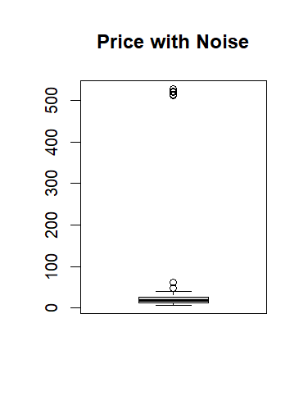
Output:

Figure 1 — Boxplot: "Price with Noise"
Artificial noise is injected into a numeric feature (Price, by adding 500 to 5 rows so they become unrealistic outliers) and a categorical feature (Type, by assigning an invalid label 'Ultra', which is not one of the original categories, to 3 rows). The boxplot clearly shows the 5 injected points as extreme outliers far above the rest of the data.
Code - Detecting and handling noise:

price_limit <- mean(mydata$Price) + 3 * sd(mydata$Price)
price_check <- mydata$Price > price_limit
print(sum(price_check))
mydata$Price[price_check] <- median(mydata$Price)

type_check <- mydata$Type == "Ultra"
print(sum(type_check))
mydata$Type[type_check] <- "Small"
mydata$Type <- factor(mydata$Type)

boxplot(mydata$Price, main = "Price after Noise Handling")
Output:

> price_limit <- mean(mydata$Price) + 3 * sd(mydata$Price)
> price_check <- mydata$Price > price_limit
> print(sum(price_check))
[1] 1
> mydata$Price[price_check] <- median(mydata$Price)
>
> type_check <- mydata$Type == "Ultra"
> print(sum(type_check))
[1] 3
> mydata$Type[type_check] <- "Small"
> mydata$Type <- factor(mydata$Type)
>
> boxplot(mydata$Price, main = "Price after Noise Handling")
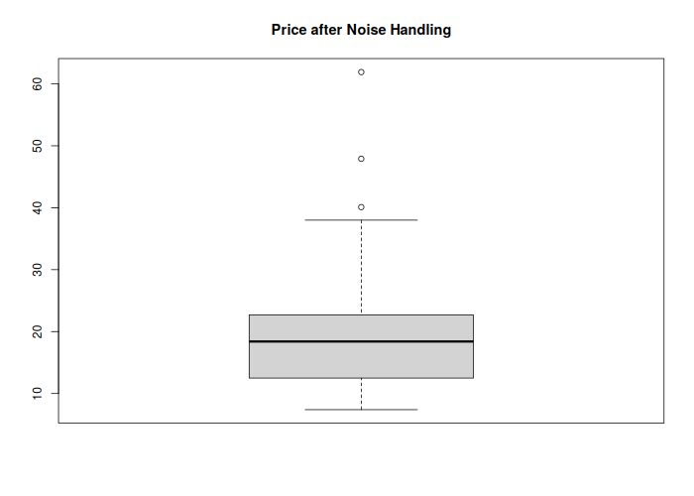
Figure 2 — Boxplot: "Price after Noise Handling"
Noisy numeric values are flagged using the mean + 3×SD rule. Although noise was deliberately added to 5 observations, only 1 observation exceeded the threshold because the extreme values increased both the mean and standard deviation. This highlights a limitation of the mean + 3×SD approach when extreme outliers are present. The detected value was replaced with the median Price. Noisy categorical values are flagged as any Type equal to the invalid label 'Ultra', correctly identifying all 3 injected rows, which are then replaced with a valid category. The 'after' boxplot confirms the extreme values are gone.

6. Invalid Data Checking
Code:

print(sum(mydata$Price <= 0))
print(sum(mydata$MPG.city <= 0))
print(sum(mydata$Horsepower <= 0))
print(sum(mydata$Passengers < 1))
Output:

> print(sum(mydata$Price <= 0))
[1] 0
> print(sum(mydata$MPG.city <= 0))
[1] 0
> print(sum(mydata$Horsepower <= 0))
[1] 0
> print(sum(mydata$Passengers < 1))
[1] 0

Invalid data checks confirm that no row contains a non-positive Price, MPG, or Horsepower value, and no row has a Passengers count below 1. This confirms that after noise handling the dataset is logically consistent.

7. Data Normalization and Transformation
Code - Min-Max Normalization:

price_min <- min(mydata$Price)
price_max <- max(mydata$Price)
mydata$Price.norm <- (mydata$Price - price_min) / (price_max - price_min)
print(summary(mydata$Price.norm))

hp_min <- min(mydata$Horsepower)
hp_max <- max(mydata$Horsepower)
mydata$Horsepower.norm <- (mydata$Horsepower - hp_min) / (hp_max - hp_min)
Output:

Min. 1st Qu. Median Mean 3rd Qu. Max.
0.00000 0.09358 0.20183 0.22200 0.28073 1.00000

Min-max normalization, using the standard formula (x - min(x)) / (max(x) - min(x)) as taught in class, rescales Price and Horsepower into the range 0 to 1, removing the effect of differing measurement scales so features become comparable.
Code - Log Transformation:

mydata$Price.log <- log(mydata$Price)
print(summary(mydata$Price.log))
Output:

Min. 1st Qu. Median Mean 3rd Qu. Max.
2.001 2.526 2.912 2.867 3.122 4.126

A log transformation is applied to Price to reduce right-skewness caused by a small number of high-priced luxury vehicles, producing a more symmetric distribution suitable for modeling.

8. Outlier Detection
Code:

boxplot(mydata$Price, main = "Boxplot of Price")
boxplot(mydata$Horsepower, main = "Boxplot of Horsepower")

Q1 <- quantile(mydata$Price, 0.25)
Q3 <- quantile(mydata$Price, 0.75)
IQR_price <- Q3 - Q1
lower <- Q1 - 1.5 * IQR_price
upper <- Q3 + 1.5 * IQR_price
outliers <- mydata$Price[mydata$Price < lower | mydata$Price > upper]
print(outliers)
print(length(outliers))
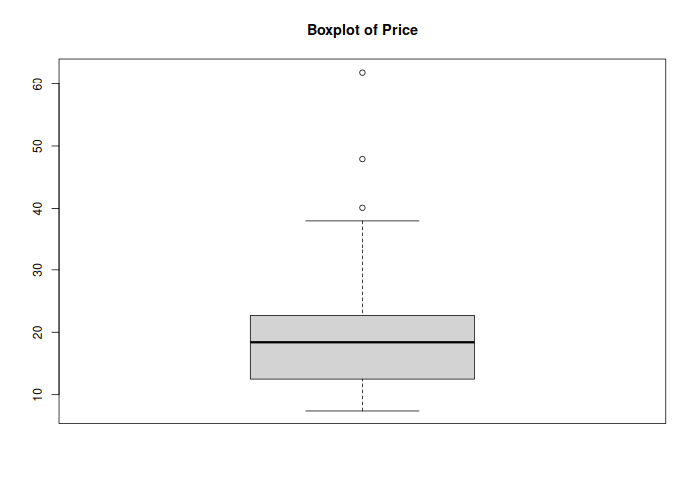
Figure 3 — Boxplot: "Boxplot of Price"
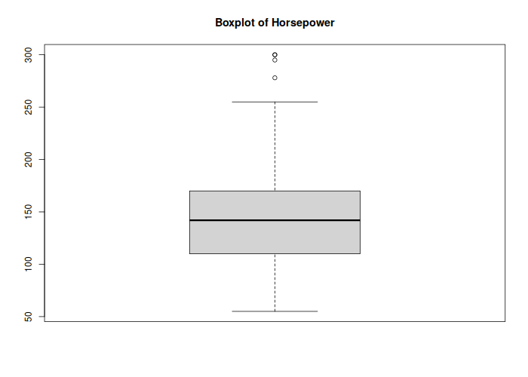
Figure 4 — Boxplot: "Boxplot of Horsepower"
Output:

[1] 40.1 47.9 61.9
[1] 3

Outliers are identified using the 1.5xIQR rule on Price. The boxplots visually confirm 3 high-price luxury vehicles as clear outliers above the upper whisker (values 40.1, 47.9, and 61.9), consistent with the numerical IQR-based detection.

9. Descriptive Statistics (with Plots)
Code:

print(summary(mydata))
print(sd(mydata$Price))
print(sd(mydata$Horsepower))
print(mean(mydata$Price))
print(median(mydata$Price))
print(var(mydata$Price))

hist(mydata$Price, main = "Histogram of Price", xlab = "Price")
hist(mydata$MPG.city, main = "Histogram of MPG City", xlab = "MPG City")
barplot(table(mydata$Type), main = "Car Type Distribution")
plot(mydata$Horsepower, mydata$Price, main = "Price vs Horsepower")
Output:

> print(summary(mydata))
rownames Manufacturer Model
Min. : 1 Length :93 Length :93
1st Qu.:24 N.unique :32 N.unique :93
Median :47 N.blank : 0 N.blank : 0
Mean :47 Min.nchar: 3 Min.nchar: 2
3rd Qu.:70 Max.nchar:13 Max.nchar:14
Max. :93

Type Min.Price Price
Compact:16 Min. : 6.70 Min. : 7.40
Large :11 1st Qu.:10.80 1st Qu.:12.50
Midsize:21 Median :14.70 Median :18.40
Small :23 Mean :17.13 Mean :19.03
Sporty :14 3rd Qu.:20.30 3rd Qu.:22.70
Van : 8 Max. :45.40 Max. :47.90

Max.Price MPG.city MPG.highway
Min. : 7.9 Min. :15.00 Min. :20.00
1st Qu.:14.7 1st Qu.:18.00 1st Qu.:26.00
Median :19.6 Median :21.00 Median :28.00
Mean :21.9 Mean :22.37 Mean :29.09
3rd Qu.:25.3 3rd Qu.:25.00 3rd Qu.:31.00
Max. :80.0 Max. :46.00 Max. :50.00

AirBags DriveTrain Cylinders
Driver & Passenger:15 4WD :10 Length :93
Driver only :45 Front:67 N.unique : 6
None :33 Rear :16 N.blank : 0
Min.nchar: 1
Max.nchar: 6

EngineSize Horsepower RPM
Min. :1.000 Min. : 55.0 Min. :3800
1st Qu.:1.800 1st Qu.:110.0 1st Qu.:4800
Median :2.400 Median :142.0 Median :5200
Mean :2.668 Mean :144.5 Mean :5281
3rd Qu.:3.300 3rd Qu.:170.0 3rd Qu.:5750
Max. :5.700 Max. :300.0 Max. :6500

Rev.per.mile Man.trans.avail Fuel.tank.capacity
Min. :1320 Length :93 Min. : 9.20
1st Qu.:1985 N.unique : 2 1st Qu.:14.50
Median :2340 N.blank : 0 Median :16.40
Mean :2332 Min.nchar: 2 Mean :16.66
3rd Qu.:2565 Max.nchar: 3 3rd Qu.:18.80
Max. :3755 Max. :27.00

Passengers Length Wheelbase
Min. :2.000 Min. :141.0 Min. : 90.0
1st Qu.:4.000 1st Qu.:174.0 1st Qu.: 98.0
Median :5.000 Median :183.0 Median :103.0
Mean :5.086 Mean :183.2 Mean :103.9
3rd Qu.:6.000 3rd Qu.:192.0 3rd Qu.:110.0
Max. :8.000 Max. :219.0 Max. :119.0

Width Turn.circle Rear.seat.room
Min. :60.00 Min. :32.00 Min. :19.00
1st Qu.:67.00 1st Qu.:37.00 1st Qu.:26.00
Median :69.00 Median :39.00 Median :27.50
Mean :69.38 Mean :38.96 Mean :27.83
3rd Qu.:72.00 3rd Qu.:41.00 3rd Qu.:30.00
Max. :78.00 Max. :45.00 Max. :36.00
NAs :2
Luggage.room Weight Origin
Min. : 6.00 Min. :1695 non-USA:45
1st Qu.:12.00 1st Qu.:2620 USA :48
Median :14.00 Median :3040
Mean :13.89 Mean :3073
3rd Qu.:15.00 3rd Qu.:3525
Max. :22.00 Max. :4105
NAs :11
Make Price.norm Horsepower.norm
Length :93 Min. :0.0000 Min. :0.0000
N.unique :93 1st Qu.:0.1259 1st Qu.:0.2245
N.blank : 0 Median :0.2716 Median :0.3551
Min.nchar: 7 Mean :0.2872 Mean :0.3652
Max.nchar:24 3rd Qu.:0.3778 3rd Qu.:0.4694
Max. :1.0000 Max. :1.0000

Price.log
Min. :2.001
1st Qu.:2.526
Median :2.912
Mean :2.854
3rd Qu.:3.122
Max. :3.869

> print(sd(mydata$Price))
[1] 8.494589
> print(sd(mydata$Horsepower))
[1] 50.34611
> print(mean(mydata$Price))
[1] 19.03118
> print(median(mydata$Price))
[1] 18.4
> print(var(mydata$Price))
[1] 72.15804
>
> hist(mydata$Price, main = "Histogram of Price", xlab = "Price")
> hist(mydata$MPG.city, main = "Histogram of MPG City", xlab = "MPG City")
> barplot(table(mydata$Type), main = "Car Type Distribution")
> plot(mydata$Horsepower, mydata$Price, main = "Price vs Horsepower")

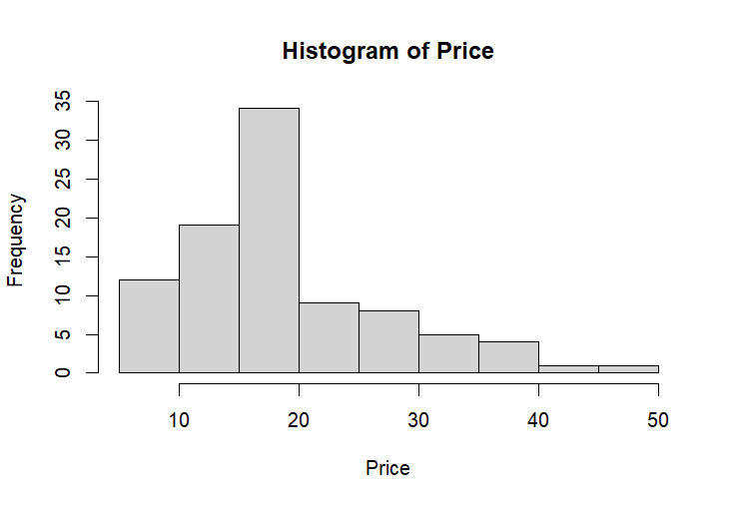

Figure 5 — Histogram: "Histogram of Price"
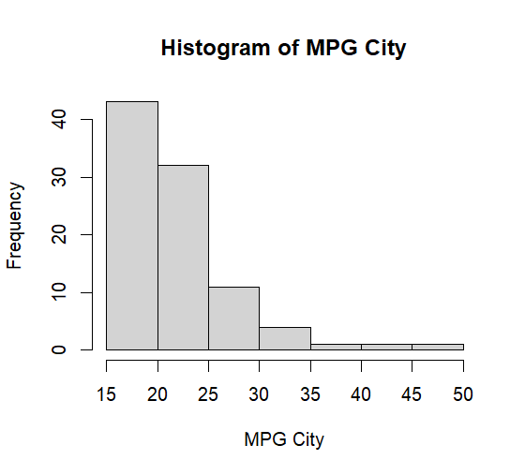

Figure 6 — Histogram: "Histogram of MPG City"

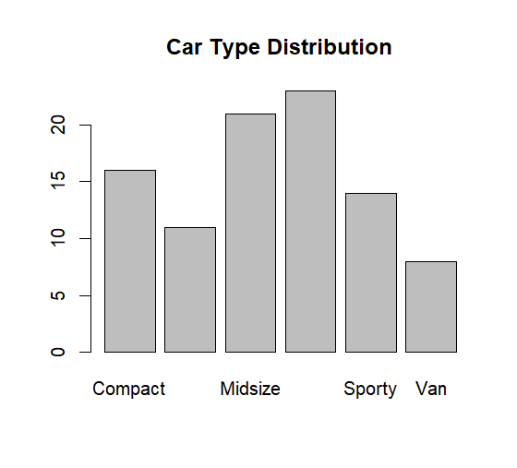

Figure 7 — Bar plot: "Car Type Distribution"

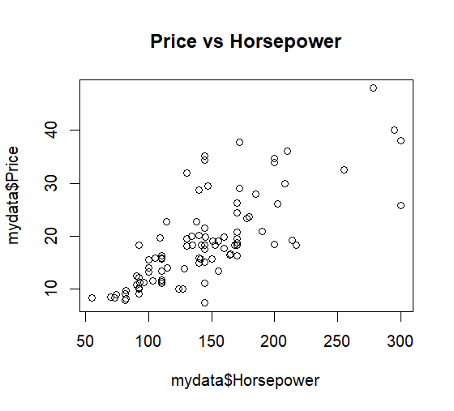

Figure 8 — Scatter plot: "Price vs Horsepower"
Descriptive statistics (mean, median, standard deviation, and variance) are computed for the numeric variables using summary(), sd(), mean(), median(), and var(). The histogram of Price is right-skewed, showing most cars priced below 25 thousand dollars with a long tail of luxury vehicles. The histogram of city MPG is concentrated between 18 and 30. The bar chart shows Small and Midsize are the most common car Types in the dataset. The scatter plot of Price versus Horsepower shows a clear positive relationship: cars with higher horsepower tend to be more expensive.

10. Dataset Split (Training 80% / Testing 20%)
Code:

n <- nrow(mydata)
train_rows <- sample(1:n, size = 0.8 * n)
train_data <- mydata[train_rows, ]
test_data <- mydata[-train_rows, ]
print(nrow(train_data))
print(nrow(test_data))
Output:

> n <- nrow(mydata)
> train_rows <- sample(1:n, size = 0.8 * n)
> train_data <- mydata[train_rows, ]
> test_data <- mydata[-train_rows, ]
> print(nrow(train_data))
[1] 74
> print(nrow(test_data))
[1] 19

The cleaned dataset of 93 rows is randomly split into a training set of 74 rows (80%) and a testing set of 19 rows (20%) using the sample() function.

11. Feature Selection
Code:

print(cor(mydata$Price, mydata$Horsepower))
print(cor(mydata$Price, mydata$Weight))
print(cor(mydata$Price, mydata$MPG.city))
print(cor(mydata$Price, mydata$EngineSize))

model <- lm(Price ~ Horsepower + Weight + EngineSize, data = train_data)
print(summary(model))
Output:

> print(cor(mydata$Price, mydata$Horsepower))
[1] 0.7574139
> print(cor(mydata$Price, mydata$Weight))
[1] 0.673642
> print(cor(mydata$Price, mydata$MPG.city))
[1] -0.6069727
> print(cor(mydata$Price, mydata$EngineSize))
[1] 0.6365766
>
> model <- lm(Price ~ Horsepower + Weight + EngineSize, data = train_data)
> print(summary(model))

Call:
lm(formula = Price ~ Horsepower + Weight + EngineSize, data = train_data)

Residuals:
Min 1Q Median 3Q Max
-10.6363 -3.3011 -0.4603 1.6851 14.6118

Coefficients:
Estimate Std. Error t value
(Intercept) -9.432226 3.978453 -2.371
Horsepower 0.113203 0.019677 5.753
Weight 0.005204 0.002034 2.559
EngineSize -1.387999 1.187888 -1.168
Pr(>|t|)
(Intercept) 0.0205 *
Horsepower 2.13e-07 ***
Weight 0.0127 *
EngineSize 0.2466
---
Signif. codes:
0 ‘***’ 0.001 ‘**’ 0.01 ‘*’ 0.05 ‘.’ 0.1 ‘ ’ 1

Residual standard error: 5.411 on 70 degrees of freedom
Multiple R-squared: 0.6152, Adjusted R-squared: 0.5987
F-statistic: 37.3 on 3 and 70 DF, p-value: 1.63e-14

The correlation of Price with each candidate numeric feature is checked using cor(). Horsepower shows the strongest positive correlation with Price (0.757), followed by Weight (0.674) and EngineSize (0.637), while MPG.city is negatively correlated (-0.607). Based on these correlations, a regression model is built using Price ~ Horsepower + Weight + EngineSize. The model summary confirms that Horsepower and Weight are statistically significant predictors of Price. The regression model explains approximately 60% of the variation in Price (Adjusted R-squared = 0.599), indicating a reasonably strong predictive relationship. This shows Horsepower and Weight are the most relevant features for predicting car Price in this dataset.

12. Conclusion
This project applied a complete data preparation pipeline to the Cars93 dataset: handling missing values by both discarding and imputation, injecting and correcting noisy numerical and categorical data, validating data ranges, normalizing and log-transforming numeric features, detecting outliers using the IQR method, computing descriptive statistics with supporting visualizations, splitting the data into training and testing sets, and performing feature selection using correlation analysis and linear regression. The resulting cleaned dataset (Cars93_cleaned.csv) and the complete R program are submitted along with this report for evaluation.

